CENWP-OD-B 12 July 2024

MEMORANDUM FOR THE RECORD

SUBJECT: 24BON026 MFR CI LPS RB3 Pacific Lamprey Mortalities

On the morning of 12 July 2024, Project Biologists discovered one Pacific Lamprey mortality in Rest Box 3 of the Cascades Island LPS (CI LPS RB3). The fish was inspected, measured, scanned for PIT tags, and returned to the river.

- Species – Pacific Lamprey (Entosphenus tridentatus)
- Origin – Unknown
- Length – 68.58cm
- Marks and tags – None
- Marks and Injuries found on carcass – None
- Cause and Time of Death –Unknown
- Future and Preventative Measures – N/A

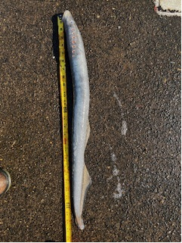

Sincerely,
Project Fisheries

